2015-PL-04-EN Graceful graphs Graceful graphs
0 ---- | I: ---- | II: ---- | III: hard | IV: medium

Answer Type: Interactive Mandatory for: Group III

Body

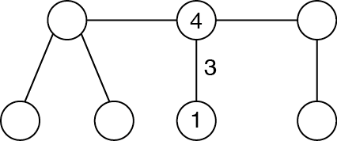

Question

The picture shows a diagram with circles and lines. You have to put the numbers 0,1, …, 6 in the circles. When two numbers are connected by a line, the line will be labeled with the difference of the two numbers.

In the diagram the numbers 1 and 4 have already been placed in two circles, and you see that the corresponding line has label 3.

Place the remaining numbers in the empty circles. Make sure that the labels for each line are different.

Answer

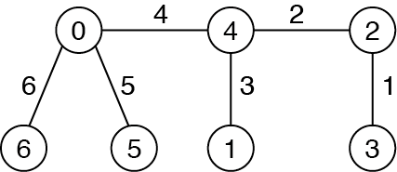

Explanation

It is easy to check that the answer is correct. There is another solution (exchange 5 and 6).

It's informatics

It is graph theory – graceful numbering of graphs, in this case it is a graceful tree.
Graphs are useful to model all kinds of real life problems, like traffic, maps, phone connections. In computer science algorithms on graphs are used frequently.

Keywords

Graceful graphs, graceful tree conjecture

Websites

http://en.wikipedia.org/wiki/Graceful_labeling

Internal Use

Wording

Graph numbering, graceful graphs, graceful trees

Comments

Maciej M Sysło, syslo@ii.uni.wroc.pl, (2015-04-10), Comment.

Comments. It is conjecture that all trees are graceful, however there is no general algorithm for finding such numbering of trees. Some other classes are also graceful, e.g. complete bipartite graphs.

Several small graphs can be used for an this task.

The task could be made harder by showing only one number in the vertex, and even more difficult not giving any number. As mentioned, different trees or graphs can be used for this task.

Graphics

Own graphics

Files

All additional files for this task (graphics, scripts, etc.)
2015-PL-04-EN Graceful graphs.odt (this file)
Graceful tree.{png,svg}
graceful tree sol.{png,svg}

Authorship

Maciej M Sysło, syslo@ii.uni.wroc.pl,
Willem moved and added some text.
Arnheidur and Eljekim changed the text in the question.
Tomohiro redrew figures.

License

Copyright © 2014 Bebras – International Contest on Informatics and Computer Fluency. This work is licensed under a Creative Commons Attribution-NonCommercial-ShareAlike 3.0 Unported License (CC BY-NC-SA 3.0). Visit: http://creativecommons.org/licenses/by-sa-sa/3.0/

